**Personal Learning Plan**

Delivery Date: 6th of November – 2016

Subject: Web Design – Home Page

Strengths: Enjoy coding

Weaknesses: Lack of free time

1. **SPECIFIC:**

I will develop the home page in the first week of october in my free hours at home, using HTML, CSS and JavaScript.

The home page is about a new product in the market, so it must be clear for the user what the product is about. It will be linked to another 3 options in the navigation bar ( Photos, Contact, Buy Now). The main page will have only basic information about the product forcing the user to navigate through the other 3 tabs for more information.

Below is the wireframe of whats need to be achieved:

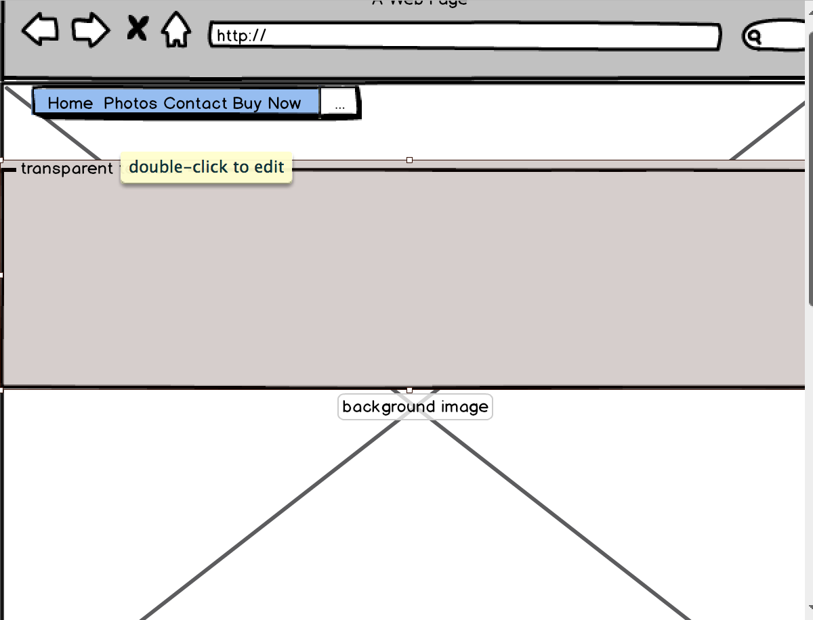

1. **MEASURABLE:**

Develop the home page, it will contain one main image in the background, a white box text area with oppacity of 80%. This text area will talk about the page, and the user still gonna be able to see through the background image.

The navigation bar will be linked with other 3 pages as requested on the requirements ( Photos, Contact, Buy Now). The colors of the page will be black, grey and white, the headline for the text area will be red.

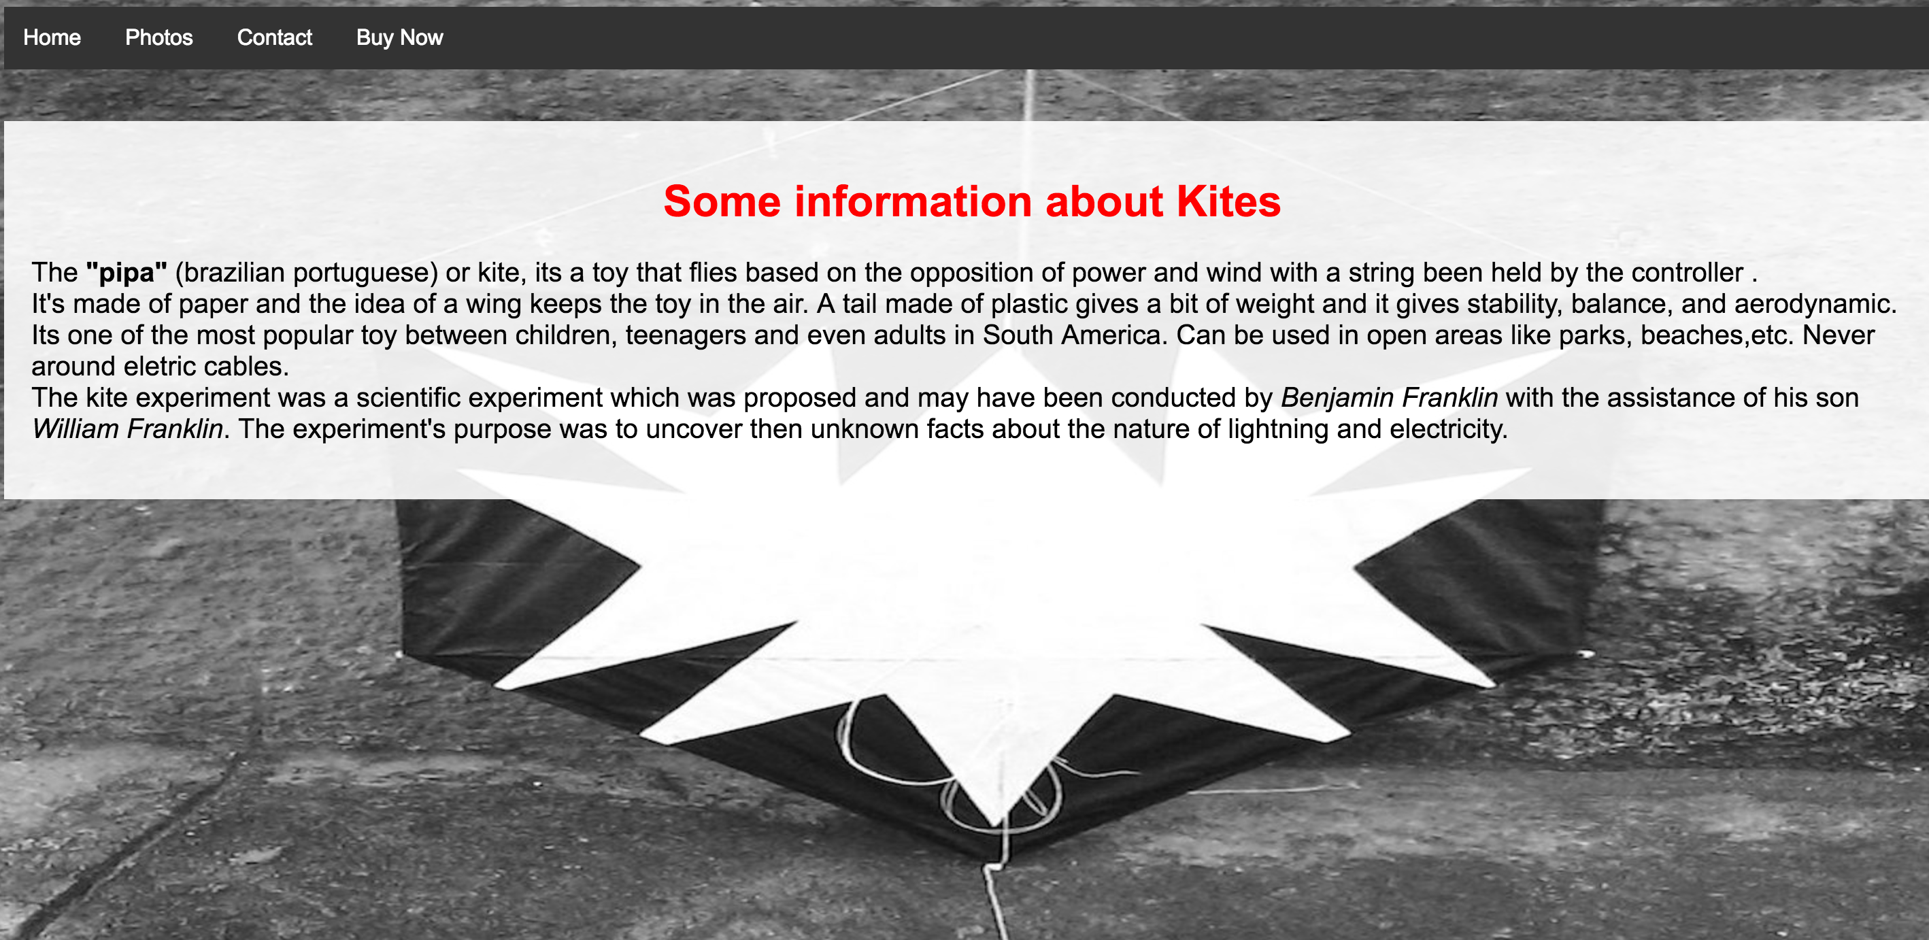

In the image above we can see the structure of it to be improved. The page will talk about kites which is very popular between teenagers in South America, with the purpose of a business in Ireland.

1. **ACHIEVABLE:**

The goal is to give some information and getting the user curious to know more about the product, forcing the user to click in the other options of the navigation bar for more information. Therefore having the user navigating through the whole page.

1. **RELEVANT:**

Having users in my home page will drive them to the other linked pages. It’s a first step for getting more popular and growing business.

1. **TIME-BOUND:**

Having 2 people visiting the home page per week, improving the chances of having at least a new client per month. This page should take about from 5 to 6 hours to be built.

This is the first step, and the deadline for it is the 6th of November.